Patient Name | PURNIMA ACHARYA | Patient ID | 082403/2
Age/D.O.B | 060Y | Gender | F
Ref Doctor | NA | Date | 5 Aug 24
MRI Spine Lumbo Sacral Plain
Observations
Straightening of lumbar spine is seen.
Wedge collapse of D12 vertebral body is seen.
Marginal osteophytes are seen at multiple levels with associated modic changes.
Haemangioma is seen in L3 and L4 vertebral body.
Schmorl's node is seen at multiple level .
Visualized cord and conus appear normal in MR signal intensity and morphology.
No gross para-spinal soft tissue abnormality seen.
No abnormal signal is seen at conus / epiconus level.
Level | L1-L2 | L2-L3 | L3-L4 | L4-L5 | L5-S1
AP Mm | 10.2mm | 4.9mm | 6.2mm | 9.4mm | 9.6mm
L1-L2: mild diffuse disc bulge is seen causing indentation of the thecal sac. Bilateral facet joint arthropathy is seen
L2-L3: heterogeneous signal is seen with diffuse disc bulge causing grade III canal stenosis, compression of left exiting nerve root, abutment of right exiting nerve root. Ligamentum flavum hypertrophy with bilateral facet joint arthropathy is seen.
L3-L4: heterogeneous signal with diffuse disc bulge and annular tear is seen. Ligamentum flavum hypertrophy is seen with bilateral facet joint arthropathy. Grade III canal stenosis with compression of left exiting nerve root and abutment of right exiting nerve root is seen.
L4-L5: grade I anterolisthesis of L4 over L5 is seen. Heterogeneous signal with diffuse disc bulge is seen along with ligamentum flavum hypertrophy causing grade III canal stenosis and compression of bilateral exiting nerve roots at the neural foramina. Bilateral facet joint arthropathy is seen
L5-S1: mild diffuse disc bulge is seen causing abutment of bilateral traversing nerve roots, right exiting nerve root.
Impression
Severe lumbar spondylosis as described.
Schmorl's nodes and marginal osteophytes with associated with modic changes at multiple levels.
Key Images
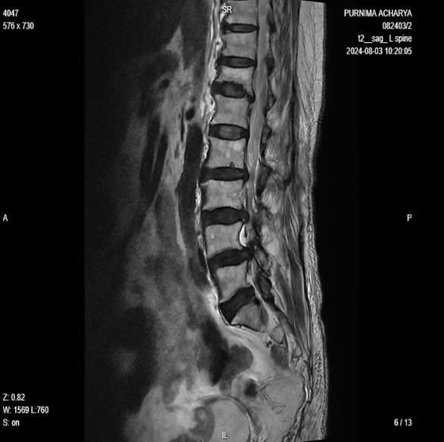
Image 1
Reported By,
Dr. Sayani Mahal
MBBS, MD
Consultant Radiologist
WBMC - 74369
Disclaimer
This medical diagnostic report is generated based on the image and patient information obtained from the source of origin, 5C Network assumes no responsibility for errors or omission of or in the image, or in the contents of the report, which are a direct interpretation of the image sent from source. In no event shall 5C Network be liable for any special, direct, indirect, consequential, or incidental damages or any damages whatsoever, whether in an action of negligence or other tort, arising out of or in connection with the use of the 5C Network Service or the contents of the Service. This report does not replace professional medical advice, additional diagnoses, or treatment.
Kindly call Help Desk (+91-95872 74858) for any report related query.
Powered by 5C Network. All Rights Reserved.

